--When you write a recursive function, you have to tell it when to stop  
recursing

* *every recursive function has two parts: the base  
  case, and the recursive case*

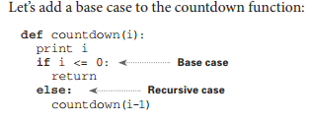

*when you call a function from another  
function, the calling function is paused in a partially completed state.*

All function calls go onto the call stack.  
The call stack can get very large, which takes up a lot of memory.